

**ARC GAUGE SET INSTRUCTIONS/TROUBLESHOOTING**

**GENERAL FITMENT AND CONNECTIONS:**

Wiring pinouts must be followed as per back of individual gauge.   
-All gauges should be mounted away from any form of interference (ignition coils, battery cables etc)  
-All gauge connections must be to a good 12v fused, switched power source (ignition switch). In a 24V application, the voltage dropping resistors supplied must be used   
-All earths must be clean (free of paint and rust)  
-All sender wiring should be run separate to starter/alternator or distributor wiring.  
-All senders should be free of thread tape and if fitted to external sender blocks, separately earthed  
-Only one backlight wire on each gauge can be connected at once – these require 12v input ie headlight switch (speedometer and tachometer must be powered for backlight to work)  
-External button is optional – if connecting, wiring comes from gauge to one terminal of the button, and the other terminal is to earth.

-Fuel gauge requires 10-180ohm sender (not included)

**SPEEDOMETER INSTRUCTIONS:**

White “Speed Pulse Signal” wire to be connected to output of pulse generator – inductive or hall effect sender can be used or an input from an ECU can also be used – pulse per km range must be between 1000-65539

To calibrate the gauge using the inbuilt learn function, hold the button whilst powering on the gauge. Use the button to scroll through the menu until “Learn” is shown. Wait until the screen shows “000000” then drive the vehicle exactly 1 km – the more accurate the distance, the more accurate the gauge will be – the 1km distance can be driven at any speed. Press the button at the end of 1km to save the calibration. During calibration, the needle will not move, and the numbers will climb on the screen. Once the button is pressed and the calibration is saved the needle will display the correct speed, the odometer will then be displayed.

To set odometer or speed warning – hold button whilst powering on, click button until ODO/BUZZ is shown, release button. After 2-3 seconds the screen will show the current setting. Use the button to change the flashing digit and waiting 2-3 seconds to change to the next digit. Once complete the gauge will return to odometer reading. Then disconnect the Power and GND and reconnect, this will save the setting. Odometer can be input 0-99999km, speed warning 10-240km/h. **Please Note: Speedometer speed warning is pre-set to 70kmh**

**TACHOMETER INSTRUCTIONS:**

Tachometer signal must be hooked to negative side of coil or tach output if using an ignition box (MSD etc) or W terminal on alternator if using in diesel application.

Voltage output and emergency status wires must not be connected.

To set RPM ratio, hour meter or overspeed buzzer - hold button whilst powering on, click button until PULSE/HOUR/BUZZ is shown, release button. After 2-3 seconds the screen will show the current setting. Use the button to change the flashing digit and waiting 2-3 seconds to change to the next digit.

Once complete the gauge will return to hour meter – Then disconnect the Power and GND and reconnect, this will save the setting.

RPM Pulse Settings (When using single coil) – Pulse setting can be tailored to signal input for different coil/signal arrangements

|  |  |
| --- | --- |
| Number of cylinders (4 stroke) | Pulse Setting |
| 4 | P00200 |
| 6 | P00300 |
| 8 | P00400 |

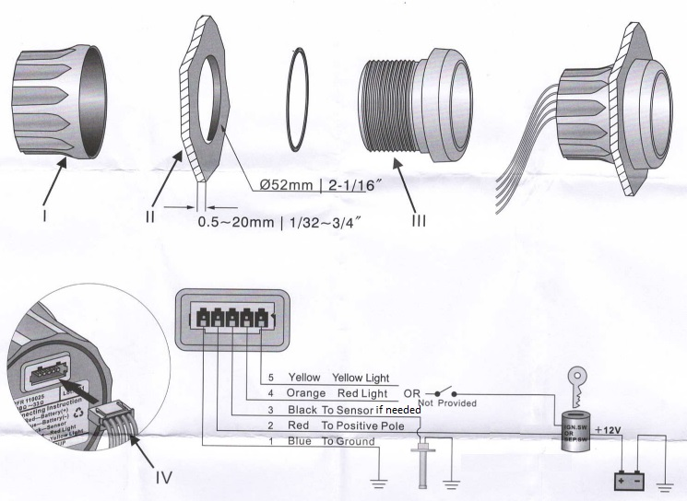**WIRING PINOUTS**

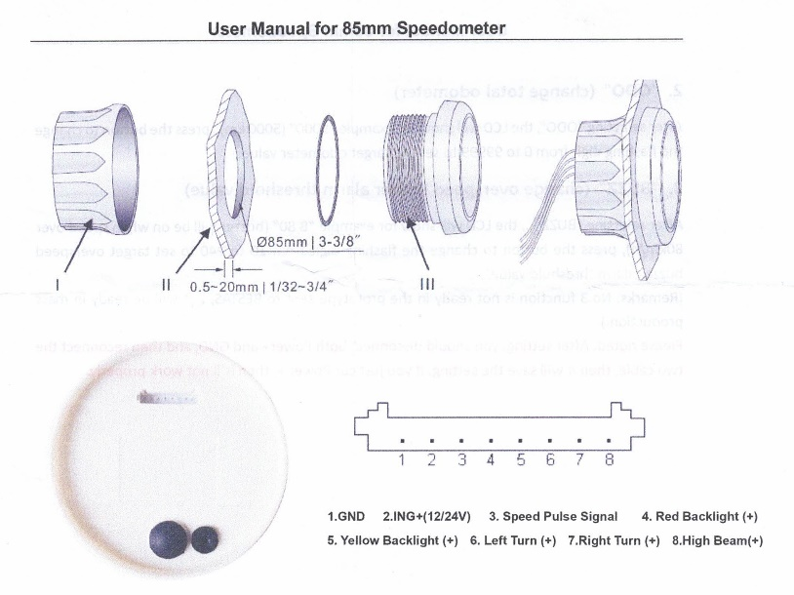

**TROUBLESHOOTING:**

In the event of a suspected faulty gauge, reconfirm each gauge has correct battery (12v) and no volt drop on earth lines, all sender lines are ok and that each plug is completely seated before continuing.

A common issue with gauges is EMI (electromagnetic interference) this can be from the wiring or gauges being physically too close to sources of interference (large power cables, ignition components, other control units) This can cause erratic readings or bouncing needs. Second to this is poor power supply/earth connections.

Most tachometer issues are incorrect pulse calibrations, although on 4 and some 6 cylinder applications slight “bouncing” of the needle can occur – this is due to the sample rate of the gauge and what keeps them fast moving and accurate. If excessive “bounce” occurs, a 10kohm resistor can be installed inline of the tach signal line. If there is no change to the signal, the resistor can be moved to between the signal and power of the gauge. Slight bounce may be unavoidable in smaller cylinder engines.

Overtightening gauge senders can lead to incorrect readings – as does poor sender earths. Sealant is not normally needed on NPT fittings, but if needed, hydraulic sealant is to be used. Thread tape is not to be used.

**WARRANTY:**

All gauges come with 12 month warranty

All suspected faulty gauges must be returned for inspection before replacement/refund.