Small Block Chevy 283-400 Serpentine Front Drive Kit Install Instructions

Box | Description
1 | Universal AC Compressor w/ Pulley, Fitting & Hardwares
2 | Universal Alternator w/ Pulley & Hardwares
3 | Universal Belt Tensioner & Hardwares
4 | Universal Idler Pulley & Hardwares
5 | SBC Long Water Pump w/ Pulley & Hardwares
6 | SBC Crank Pulley Spacer & Hardwares
7 | SBC Crank Pulley & Hardwares
8 | GM Type II Power Steering Pump w/ Reservoir, Pulley & Hardwares
9 | SBC Main Bracket
10 | SBC 8 Rib Belt - 1930mm

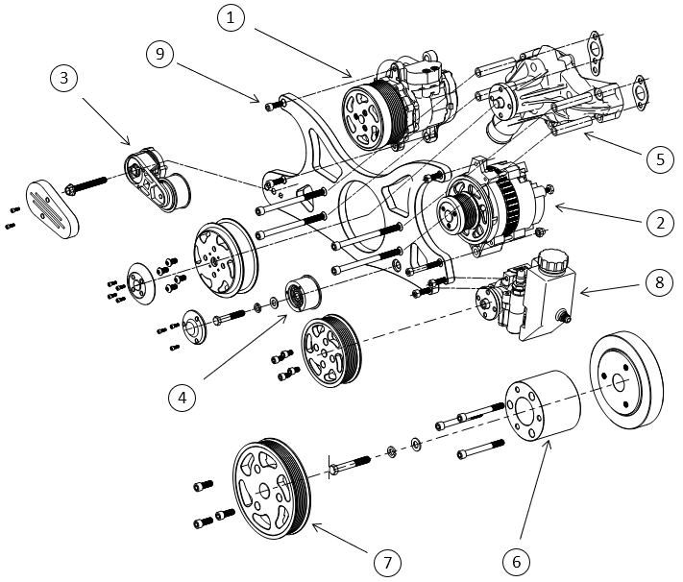

Small Block Chevy 283-400 Serpentine Front Drive Kit Install Instructions

Hardwares Pack List
Pack | Description | Comments | Qty
1 | M8*25 SHCS | Bolts for AC Compressor | 2
2 | M8*25 SHCS | Bottom Alternator Bolt | 1
2 | M8*65 SHCS | Top Alternator Bolt | 1
2 | M8 Cap Nut | Nut for Top Alternator Bolt | 1
3 | 3/8-16*5.5" SHCS | Bolts for Water Pump to Bracket | 4
3 | 80mm Drivepipe | Drivepipes for Water Pump | 4
3 | Sealing Gasket | Sealing Gasket for Water Pump | 2
4 | 3/8-16*3" Hexagon Bolt | Bolt for Belt Tensioner | 1
4 | 3/8-16 Self-locking Nut | Nut for Belt Tensioner Bolt | 1
5 | 3/8-24*3.75" SHCS | Bolts for Crank Spacer | 3
5 | 7/16-14*3" Hexagon Bolt | Bolt for Crank Spacer | 1
5 | 7/16 Plain Washer | Washer Between Crank spacer&Balancer | 1
5 | 7/16 Spring Washer | Washer Between Crank spacer&Balancer | 1
6 | 3/8-16*1"SHCS | Bolts for Crank Pulley | 3
7 | M8*30 SHCS | Bolts for Power Steering Pump | 2

