E43711-Small Block Ford 289-351W Serpentine Front Drive Kit Install Instructions
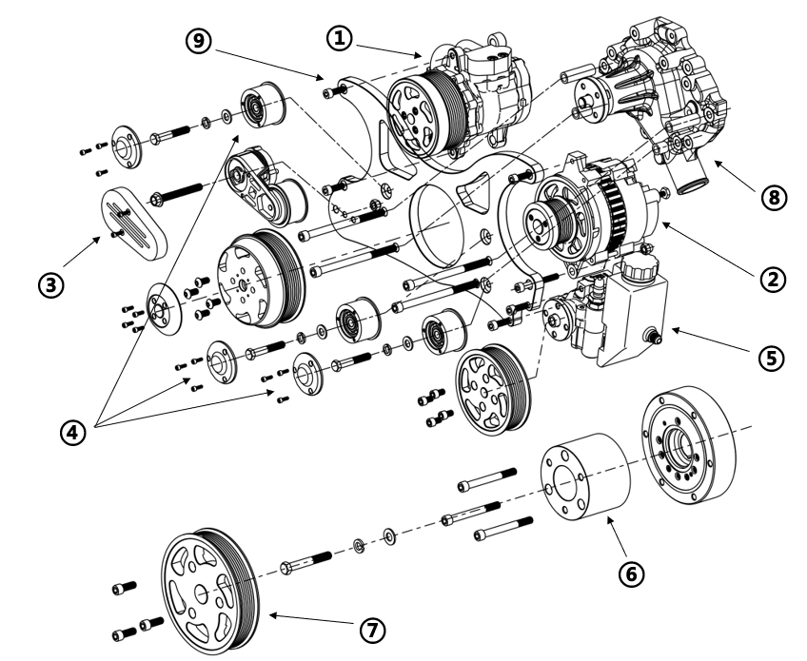
Box | Description
1 | Universal AC Compressor w/ Pulley, Fitting & Hardwares
2 | Universal Alternator w/ Pulley & Hardwares
3 | Universal Belt Tensioner & Hardwares
4 | Universal Idler Pulley & Hardwares
5 | Universal GM Type II Power Steering Pump w/ Reservoir, Pulley & Hardwares
6 | SBF Crank Pulley Spacer & Hardwares
7 | Universal Crank Pulley & Hardwares
8 | SBF Short Water Pump w/ Pulley, Spacers & Hardwares
9 | SBF Main Bracket
10 | SBF 8 Rib Belt - 1980mm

Hardwares Pack List
Pack | Description | Comments | Qty
1 | M8*25 SHCS | Bolts for AC Compressor | 2
2 | M8*25 SHCS | Bottom Alternator Bolt | 1
2 | M8*65 SHCS | Top Alternator Bolt | 1
2 | M8 Cap Nut | Nut for Top Alternator Bolt | 1
3 | 5/16-18*6" SHCS | Bolts for Water Pump to Bracket | 4
3 | 50.8mm*2/24mm*1/16.4mm*1 Drivepipe | Drivepipes for Water Pump | 4
3 | Sealing Gasket | Sealing Gaskets for Water Pump | 1
3 | 5/16-18*2" SHCS | Bolts for Water Pump to Timing Chain Cover | 3
3 | 5/16-18*3" SHCS | Bolts for Water Pump to Timing Chain Cover | 1
3 | 5/16 Plain Washer | Washers for Water Pump to Timing Chain Cover | 4
3 | 5/16 Spring Washer | Washers for Water Pump to Timing Chain Cover | 4
4 | 3/8-16*3" Hexagon Bolt | Bolt for Belt Tensioner | 1
4 | 3/8-16 Self-locking Nut | Nut for Belt Tensioner Bolt | 1
4 | 3/8 Plain Washer | Washer for Belt Tensioner Bolt | 1
5 | 3/8-16*3" SHCS | Bolts for Crank Spacer | 3
5 | 5/8-18*3.5" Hexagon Bolt | Bolt for Crank Spacer | 1
5 | 5/8 Plain Washer | Washer for Crank Spacer Bolt | 1
5 | 5/8 Spring Washer | Washer for Crank Spacer Bolt | 1
6 | 3/8-16*1"SHCS | Bolts for Crank Pulley | 3
7 | M8*30 SHCS | Bolts for Power Steering Pump | 2
E43711-Small Block Ford 289-351W Serpentine Front Drive Kit Install Instructions

